**MUX & De - MUX**

1. Design 16:1 MUX using 2:1 MUX

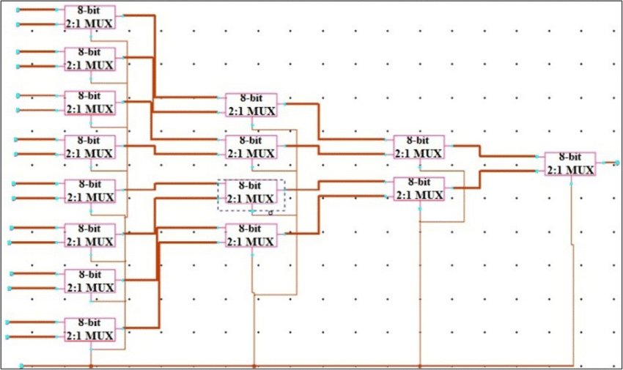Ans:

1. Design a D_FF using MUX

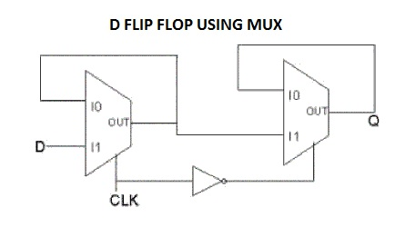Ans:

1. Design a 1:2 DEMUX that can be used as an inverter & also as a buffer.

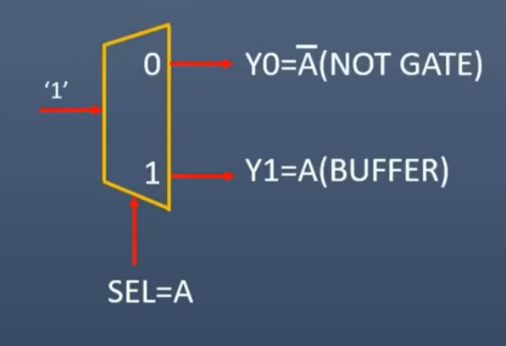Ans:

1. Design a NAND gate using 1:2 DEMUX

Ans:

1. What is the difference between Decoder & DEMUX?

Ans:

|  |  |  |  |  |  |  |  |  |  |  |  |  |  |  |  |  |  |  |  |  |  |
| --- | --- | --- | --- | --- | --- | --- | --- | --- | --- | --- | --- | --- | --- | --- | --- | --- | --- | --- | --- | --- | --- |
| |  |  |  | | --- | --- | --- | | **Key** | **Decoder** | **Demultiplexer** | | Purpose | A decoder decodes an encrypted input signal to multiple output signals from one format to another format. | A demultiplexer routes an input signal to multiple output signals. | | Input / Output | A decoder has input lines and a maximum of {2} ^ {n} output lines. | A demultiplexer has single input, selection lines and maximum of {2} ^ {n} outputs. | | Inverse | Decoder's inverse is Encoder. | Demultiplexer's inverse is Multiplexer. | | Usage | Decoders are used to detect bits, encoding of data. | Demultiplexers are used in switching, data distribution. | | Select Lines | Decoders have no select lines. | Demultiplexers contain select lines. | | Application | Decoders are heavily used in networking applications. | Demultiplexers are employed in communication systems. | |

1. If D0 input of a 2:1 MUX is connected to ground, what is the output?

Ans: In a 2:1 multiplexer (MUX), the output depends on the state of the select line (S) and the inputs D0 and D1. Here's how it works when D0 is connected to ground:

1. If S=0, the output will be D0.
2. If S=1, the output will be D1.

Since D0D0D0 is connected to ground (logic 0):

* When S=0, the output will be 0.
* When S=1, the output will be D1, as it will pass the value of D1 to the output.

So, the output will be:

* 0 when S=0S = 0S=0
* D1 when S=1

1. If D1 input of 2:1 MUX is connected to 1, what is the output?

Ans: If the D1 input of a 2:1 MUX is connected to logic 1, the output will depend on the state of the select line S and the D0 input. Here's how the output is determined:

1. When S=0, the output is D0.
2. When S=1, the output is D1.

Since D1D1D1 is connected to logic 1:

* When S=0, the output will be D0.
* When S=1, the output will be 1.

So, the output will be:

* D0 when S=0
* 1 when S=1

1. List the applications of:
   1. Multiplexer

Ans:

* Implementation of Digital Circuits
* Control Unit of CPU
* Parallel to Serial Data Conversion
* Computer Memory
* Data Routing
* Communication Systems
  1. Demultiplexer
* DEMUXs are majorly used to design the ALU circuits and parallel data segments.
* The DEMUXs convert the output of the MUX into the actual input. On the receiver end, the DEMUX can be used to verify the original form of the data to carry out the entire communication process.
* DEMUX helps to save the output. The output generally saved to the ALU. The output will be saved in the registers and the various storage units of the system.
* Each DEMUX has a connection with multiple registers which helps to store the processed data into it.
* The counterpart of the DEMUX regulates the data signal at the output stage of the DEMUX operation. These data can be retrieved later to read out parallelly.
* In the audio or video system, the DEMUX distributes them in different channels. In broadcasting, the DEMUX separates the composite signal into an individual one.